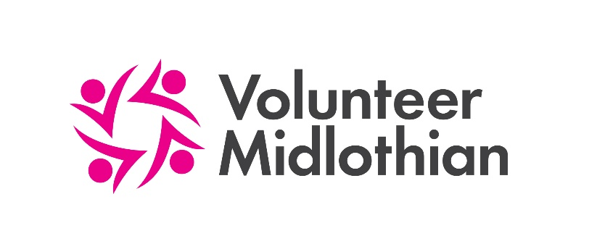

Organisation Registration Form

Please complete this form to register your organisation with Volunteer Midlothian. You will then be able to promote your volunteering opportunities with us on our website.

Main Contact
Provide details of the person who would be your preferred first point of contact.
Title: Email:
First name: Tel no:
Last name: Mobile no:
Job title/Position: Preferred contact method: Phone Email

Data Protection
Can this person’s details be shared with prospective volunteers or other organisations? Yes / No
Can this person’s details be published on the web as the main contact for this organisation? Yes / No
Would you like to receive e-bulletin updates from Volunteer Midlothian? Yes / No
Please give details of anyone else you feel it would be appropriate for us have on our contact database.
Name: Position:
E-mail: Receive e-mail bulletins?
Name: Position:
E-mail: Receive e-mail bulletins?

Membership
Volunteer Midlothian is a membership organisation. You do not need to join to promote opportunities with us, but members do receive additional benefits including extra promotion of opportunities and access to our quarterly Volunteer Managers Forum, which is great for networking and information sharing. More information about VM membership can be found on our website.

Would you like us to contact you separately about becoming a member? Yes/No

Organisation Details
1. What is the name of your organisation? FORMCHECKBOX FORMCHECKBOX FORMCHECKBOX FORMCHECKBOX

2. Please provide full address details of organisation:
Address Line 1: Email:
Address Line 2: Website:
Town/City: Phone number:
Postcode:

3. Is your organisation a registered charity? Yes/No If yes, what is the charity number?

4. Please tell us about your organisation’s main aims and objectives (e.g. a mission statement). This should be no longer than 150 words.

5. Are you part of a larger organisation? Yes/No

a.) If yes, which larger organisation?

b.) In which geographical areas do you operate?
Specific local neighbourhoods in Midlothian
Local Authority wide (whole of Midlothian)
More than one local authority
Scotland wide
UK wide
International

6. What year was your organisation (or branch/project) established?

7. What is the legal status of your organisation? Please select only one which best describes your organisation.
Unincorporated association
Company Limited by Guarantee. Please give number (if applicable):
Scottish Charitable Incorporated Organisation (SCIO)
Community Interest Company (CIC)
Industrial & Provident Society
Trust
Other

8. What are your organisation’s main areas of activity?
Addictions  Advice/Info  Advocacy  Animal Welfare  Arts/Culture  Befriending/Mentoring  BAME Communities  Campaigning/Lobbying  Carers  Charity Shop  Children/Families  Community Learning and Development | Community Transport  Conservation/Environment  Counselling  Disability  Emergency Response  Employability  Faith/Religion  Foodbanks  Health  Heritage  Horticulture/Gardening | Housing/Homelessness  Housing Association  Mental Health  Money/welfare benefits  Offenders/justice  Older people  Overseas aid and development  Poverty  Refugees/Migrants  Sport/Outdoors  Young people

Volunteering
9. Do you have the following policies and procedures in place within your organisation?
Public liability insurance
Volunteer policy
Covid-19 policy
Covid-19 risk assessments (for individual roles/and or projects)
Health and Safety at Work policy

Vulnerable Adults policy
Equality and Diversity policy

Saltire Awards Scheme

How We Use Your Information
Volunteer Midlothian does not screen or provide insurance for any volunteers it refers to your organisation. This is the responsibility of the individual organisation. The information provided by you in this form will be entered on to ‘Milo’, an ICT platform for Third Sector Interfaces (TSIs) across Scotland. It will be used to help signpost prospective volunteers to your organisation.
Any personal information you give us will be held and used in accordance with the Data Protection Act 1998. Personal information on Milo will not be disclosed to any unauthorised person or body without your permission. Only authorised Milo users will have access to the information you supply.
General organisational information will be made available to other organisations and the public through approved local and national websites (such as Volunteer Scotland). We will not display personal contact names or information unless you give us permission to do so. Anonymised statistical data gathered from our database may be used to report to our various funders.

Declaration
I can confirm that the details I have given are correct and I represent a not-for-profit organisation. I am authorised to complete this form on behalf of my organisation.
Name (please print): Position in Organisation:
Signature: Date:

Thank you for completing this form. Please email it to info@volunteermidlothian.org.uk.

