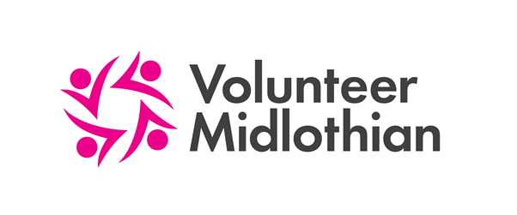
Membership for Volunteer Midlothian 2022-23

The cost of membership is £30 for the year.

Please fill in the form and return to carol@volunteermidlothian.org.uk

Organisation:
Address:
Tel:
Email:
Website:
Main contact:
Email address:

Aims/priorities of organisation:

Names and emails of all staff who wish to be on our Volunteer Managers Forum mailing list (up to three can attend at each forum meeting):

Signed: ……………………………………………………………………………………. Date: ………………………………………………..

(We will send membership acknowledgement by email unless requested otherwise.)

Please send your payment by BACS where possible as we are in the process of moving to new premises. Should you require to pay by cheque please contact me at the email address below.

Email: carol@volunteermidlothian.org.uk
Tel: 07859 914587

Please make payments by BACS to the following account:
Bank: Bank of Scotland, Dalkeith
Name of Account: Volunteer Centre Midlothian
Account No: 00548242
Sort Code: 80-06-29

